**Name:** Esmail Nabil Hassan Mohamed

**B.N:** 192

**Date:** 30/ 5/ 2020

**Topic:** Operating systems

**Github link:**

**Github page:**

**Application brief:**

An operating system is software that acts as an interface between end-user and hardware computers. The kernel is the core component of an operating computer system. The kernel's sole job is to manage the communication between the software and the hardware. Applications for desktop or laptop computers are often called desktop applications, while those for mobile devices are called smartphone apps.

Operating system allows you to hide details of hardware by creating an abstraction. It is easy to use with a GUI. It offers an environment in which a user may execute programs / applications. It has to make sure use of the computer system is convenient. It offers format that is easy to use for the computer device tools. It serves as a mediator for all of the system's hardware and software. It acts as an intermediary between the hardware components and the applications.

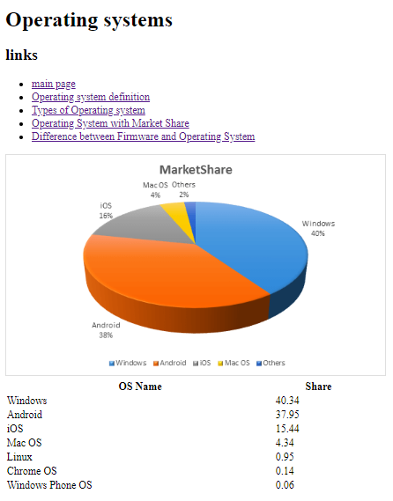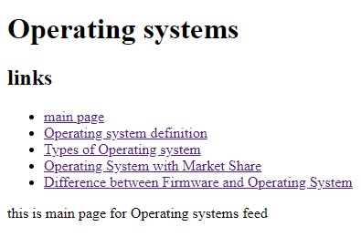**Screenshots:**

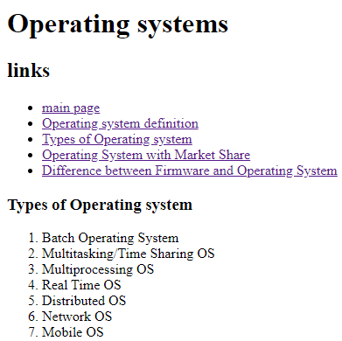

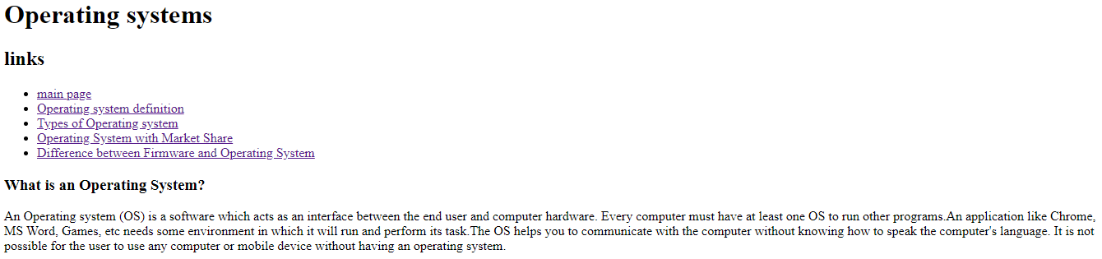

**Source code:**

